1. **Modify CSSlab5-test01.html by adding CSS in CSSLab5-test01.css to implement the layout shown in Figure below (some of the styling as already been provided) : 12 points**

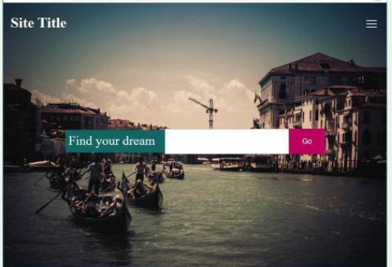

1. Set the background image on the <body> tag. Set the height to 100vh so it will always fill the entire viewport. Set the background-cover and background-position properties

2. For the header, set its display to flex. Set justify-content to space- between and align-items to center. This will make the <h2> and the <nav> elements sit on the same line, but will expand to be aligned with the outside edges.

3. To center the form in the middle of the viewport, set the display of the <main> element to flex, and align-items and justify-contents to center. Do the same for the <form> element.

4. Fine-tune the size of the form elements by setting the flex-basis of label to 16em, the search box to 36em, and the submit button to 10em. The final result should look similar to that shown in Figure above.

**Modified code:**

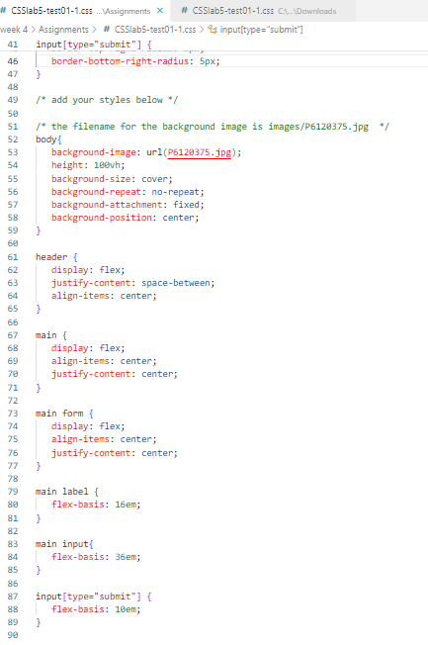

**Output:**

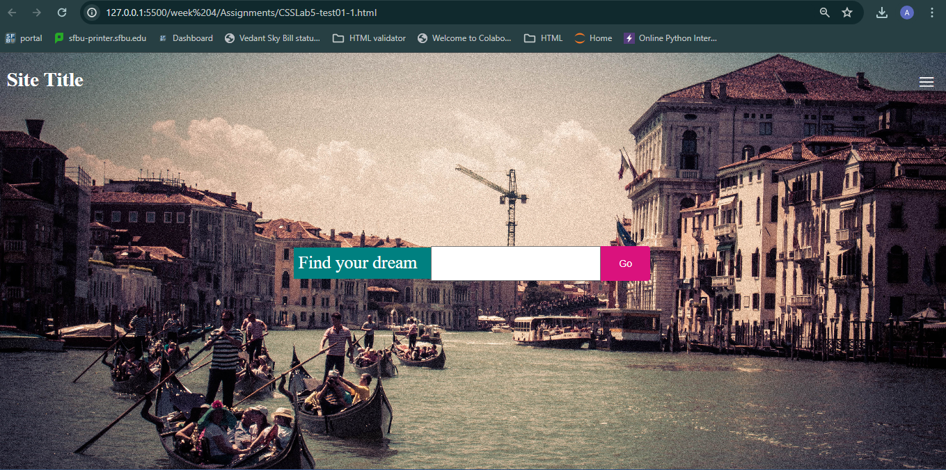

1. **Modify CSSlab5-test02.html by adding CSS in CSSlab5-test02.css to implement the lay-out shown in Figure below (some of the styling as already been provided): 9 points**

1. This layout will require two nested grids. Create the outer grid that will have one row and three columns containing the <nav>, <aside>, and <main> elements. There should be no grid gap, and the first two columns should have a minimum size of 80px and a maximum size of 200px. The third column should fill the remaining space. To make the grid fill the entire vertical space, set the height of the container to 100vh.

2. The inner grid containing the four image squares should consist of two columns

and rows. The images in the background of each square are 250px by 250px.

3. To center the text within each square, use flex layout along with align-items

and justify-content.

**Modified code:**

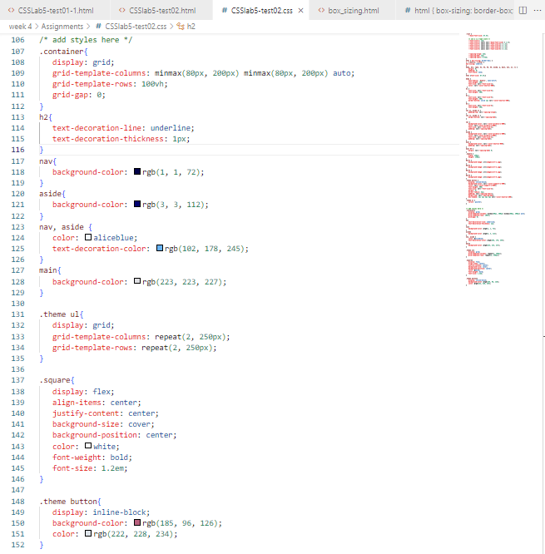

**Output:**

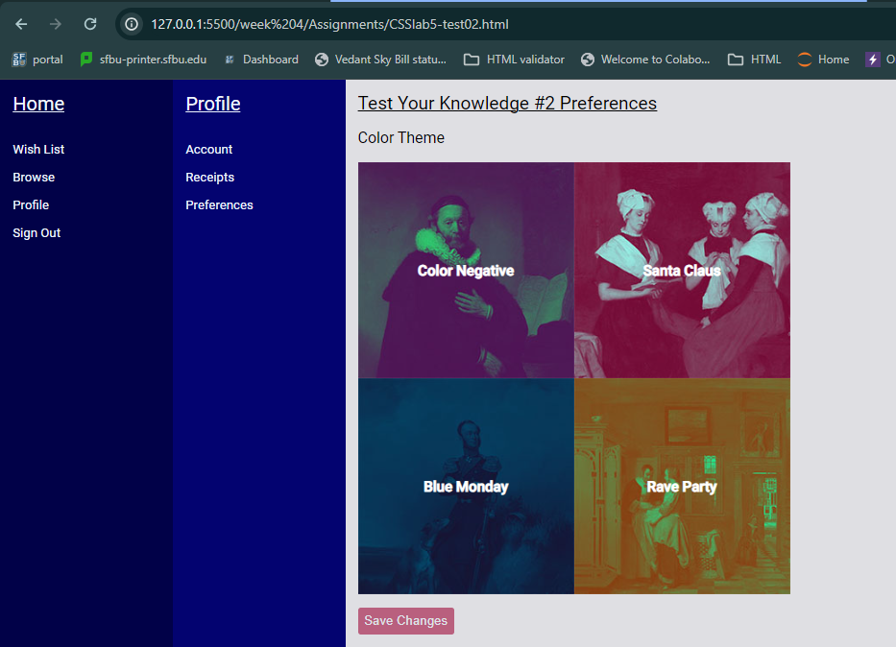

1. **Modify CSSlab5-test03.html by adding CSS in CSSlab5-test03.css to implement the layout shown in Figure below(some of the styling as already been provided) : 9 points**

1. You have been provided with a signup form layout that looks similar to the top screen in Figure . It uses a two-column grid layout (and flex within the grid cells). You need to add a media query that changes to a one-column grid when the browser width is below 1000 pixels. The second screen in Figure illustrates how it should appear at the smaller brows-er widths.

2. Your media query will have to change the margin and grid-template-columns properties of the container class. The formImage class will also need to be modi-fied in the media query so that it no longer has a background image and instead has a background-color.

3. It is quite common to increase the font size for smaller layouts. This can result in a lot of changes, but because the CSS uses variables, you only need to change the --base-font-size variable to 120% in your media query and all the other font sizes will also change. You will also need to change a few paddings and margins also (because of the use of CSS variables you should be able to simply make use of the --space-med and --spacing-small variables for those changes)

**Modified code:**

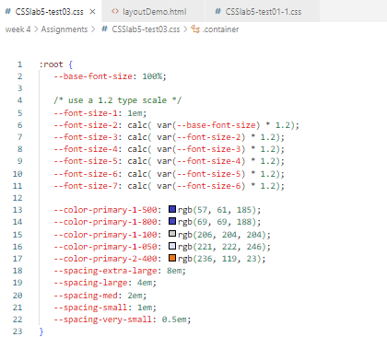

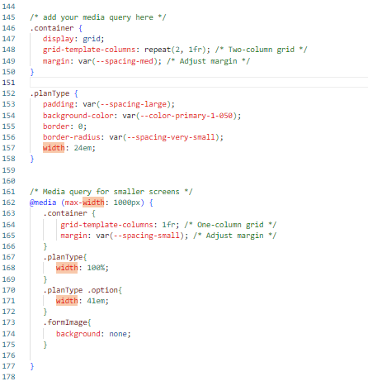

**Output:**

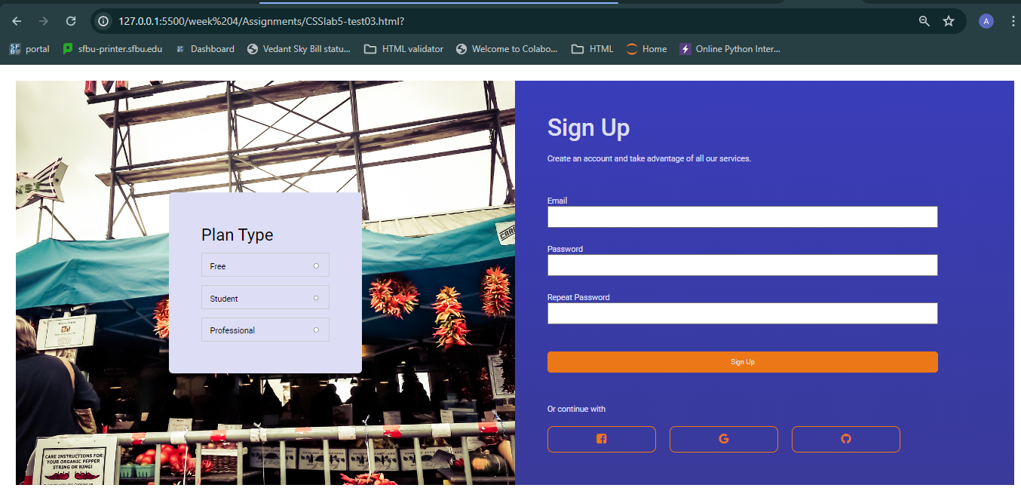

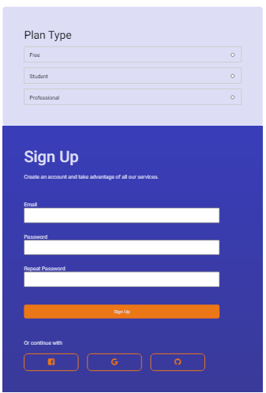

Instructions for submission :

1. Submit the screenshots of the modified code from each question

Note that absence of the screenshots will knock out 50% of the grade for the particular question irrespective of the code file.

1. Submit the html ,css files of all the questions - 2 points

Grading Rubric :

| **Criteria** | **Points** |
| --- | --- |
| Task 1: CSSlab5-test01.html and CSSlab5-test01.css |  |
| 1. Background image on <body> tag | 2 |
| 2. Header styling with display flex, justify-content, align-items | 3 |
| 3. Centering form using flex and align-items, justify-content | 3 |
| 4. Fine-tuning form element sizes | 4 |
| Total | 12 |
|  |  |
| Task 2: CSSlab5-test02.html and CSSlab5-test02.css |  |
| 1. Outer grid layout with specified column sizes and height | 3 |
| 2. Inner grid layout with specified rows and columns | 3 |
| 3. Centering text within image squares | 3 |
| Total | 9 |
|  |  |
| Task 3: CSSlab5-test03.html and CSSlab5-test03.css |  |
| 1. Media query for one-column grid below 1000 pixels | 3 |
| 2. Adjustments to margin, grid-template-columns, and background color in media query | 3 |
| 3. Font size adjustments and changes in paddings/margins | 3 |
| Total | 9 |